1. Provide a screenshot of your MySQL Workbench to show that you have successfully initialized an empty earthquakes table in the usgs database.

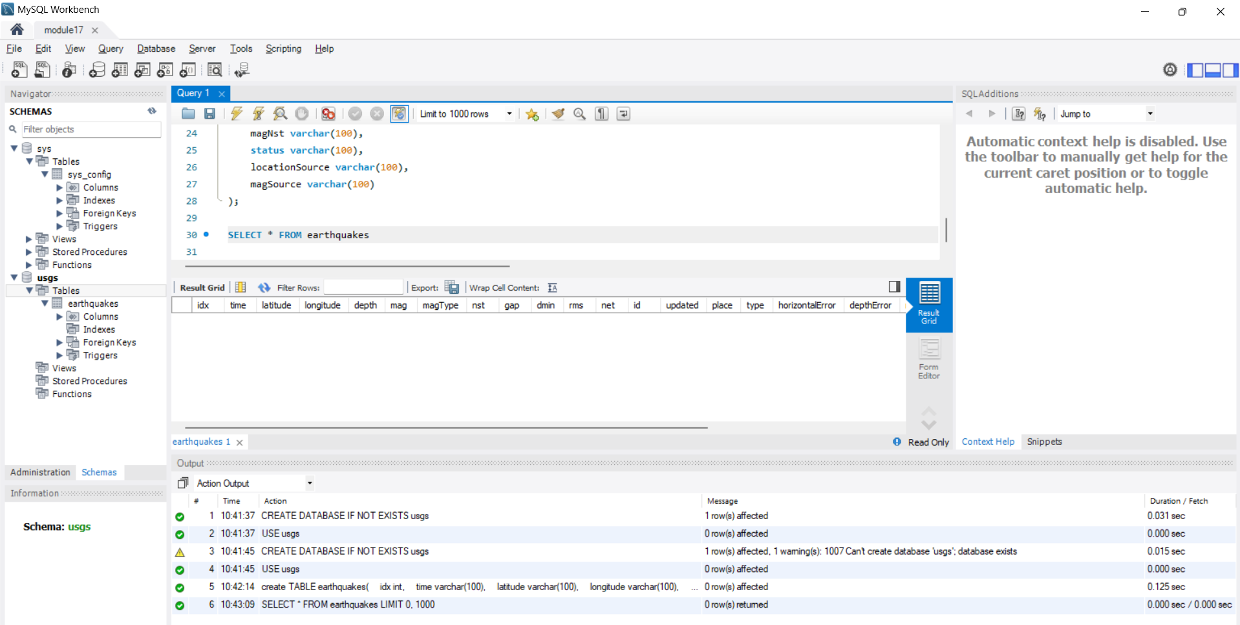

1. Provide a screenshot to show that the Activity17-2.csv CSV file is now on the NiFi *server*.

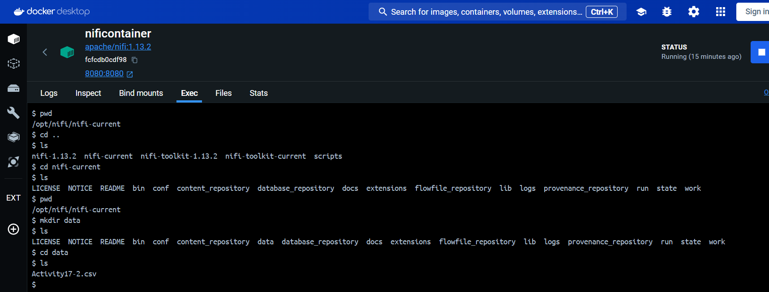

1. Provide a screenshot of the *controller* screen to show that the three *controller* services (*reader*, *writer*, and MySQL) are enabled.

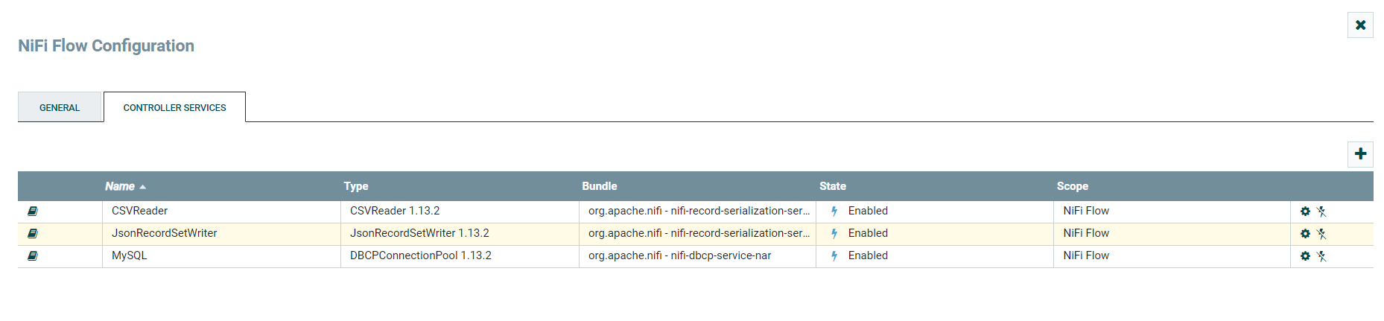

1. Provide a screenshot of your complete data pipeline, including all five *processors*: GetFile, SplitText, ConvertRecord, ConvertJSONToSQL, and PutSQL.

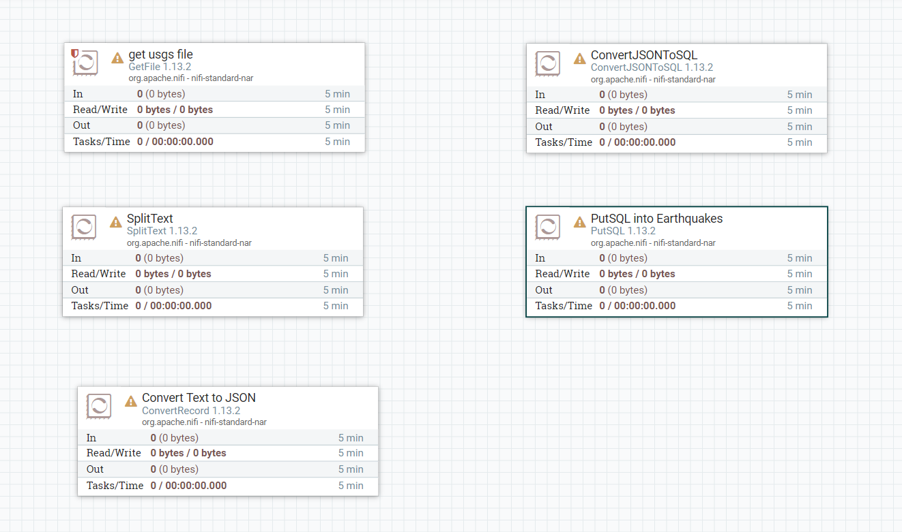

1. Provide a screenshot of all five *processors* to show that the correct connections have been made.

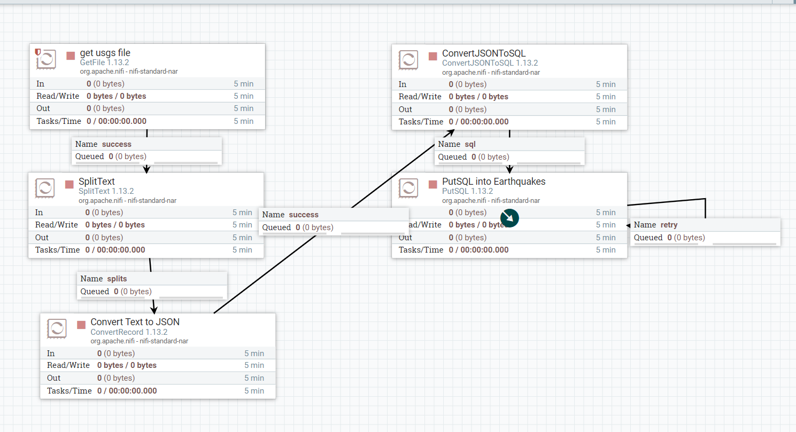

1. Provide a screenshot of your NiFi browser screen to show all five *processors* connected and running.

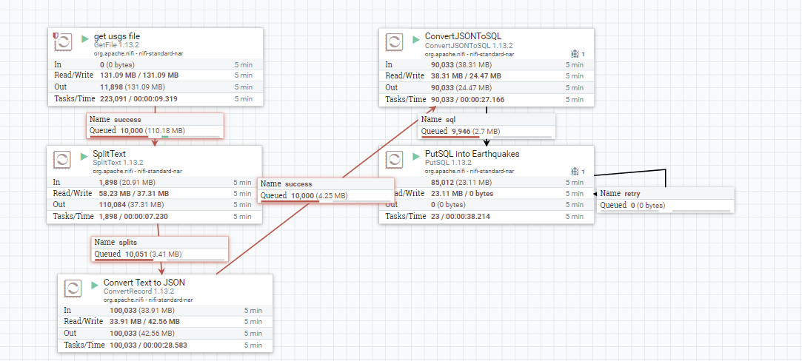

1. Provide a screenshot of the result of this *query* to show that the earthquakes table in the usgs database is now saturated with data.

